Mayank Saxena(s180020300089)

Task dated 3-7-2017

Q1) Explain regular expression and quantifiers with example code.

Ans.) Regex is an API to define pattern for searching and manipulating strings.

Widely use to define constraints on string such as password and email validation.Regex Api provides a interface and 3 classes in java.util.regex package.

java.util.regex package:

1.)MatcherResult Interface

2.)matcher class

3.)Pattern class

4.)PatternSyntaxException class

#Code

import java.util.regex.*;//matcher and pattern both included

import java.util.Scanner;

class Demo

{

public static void main(String args[])

{

Scanner sc=new Scanner(System.in);

String t="Best ever movie Dark knight ";

Pattern p = Pattern.compile("B?"+"k+"+"[a-zA-F]");//here we used quantifier B? and character class

Matcher m = p.matcher(t);

if (m.find())//doubt

{ System.out.println("Found match!");

}

else {

System.out.println("not found! ");

}

System.out.println(Pattern.matches("..b","bab"));//. represent single character

System.out.println(Pattern.matches(".ello","hello"));

System.out.println("by character classes and quantifiers ...");

System.out.println(Pattern.matches("[789]{1}[0-9]{9}", sc.nextLine())); // regular expression starting with 789 is accepted

System.out.println(Pattern.matches("[789][0-9]{9}", sc.nextLine()));

}

}

Q2) Explain DAO design pattern with example.

Ans.) Data Access Object pattern is used to separate low level data aceessing API or operation from high level business services. It is based on abstraction and encapsulation design principles and shields rest of application from any change on persistence layer i.e. it is design pattern used to create classes and interfaces in such a way, so that client can easily interact with data of database without knowing internal structure used to connect with database.

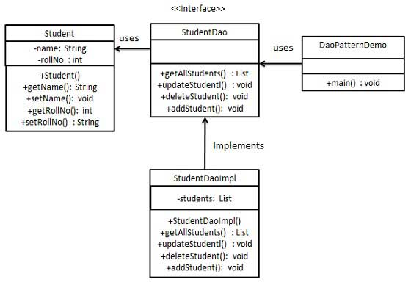

Create a Student object acting as a Model. StudentDao is Data Acees Interface.StudentDaoImpl is concrete class implementing Data Access Object Interface. DaoPatternDemo class, will use StudentDao to Demonstarte the use of Data Access Object pattern.

Q3.) . Write a note on how DAO helps in abstraction.

Ans.) **Abstraction** is the process of **abstraction in Java** is used to hide certain details and only show the essential features of the object. In other words, it deals with the outside view of an object. DAO does it same it hides the internal structure from the client and implements the interface but client doesn’t know about internal structure. As, It shields the rest of application from any change on persistence layer.